Milestone report
MILESTONE: Pre-Alpha
TEAM NAME: Noflex
GAME NAME: Q
NAME: Minjae Kyung
JOBS: Product Manager
DEGREE PROGRAM: RTIS
GAME DESCRIPTION: Our game is a side view platformer rogue-like game. Player is an eminent scientist who participated in the space project.
LINKS: https://github.com/Rudy-Castan-DigiPen-Teaching/game-project-noflex

Work Done :

Restruct Enemy AI
  - When I was making Enemy AI, my main focus was just to see my algorithm works well.
  - So I did not care about maintainability. so it was in the hell of if-else disease
  - My first goal of this vacation was to fix the structure of the enemy system.
  - To make the code maintainable, I thought that the best solution will state system.
  - It may seem weird to have a state system on components while using an ECS but I can’t think of a better way.
  - Thanks to state system, I can add other types of enemies quite easily
  - And I am trying to find another mechanism for pathfinding on platformers.
  - I tried A* path finding. But the main problem was the map is not that difficult and we should give jump information so it does not improve by just having a jump trigger on the platformer. I’ve also tried ANN training. but I trained quite a lot but haven't made any improvements.- it means it needs a lot of time to train it.
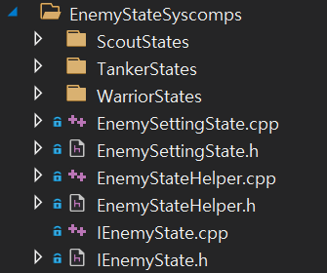
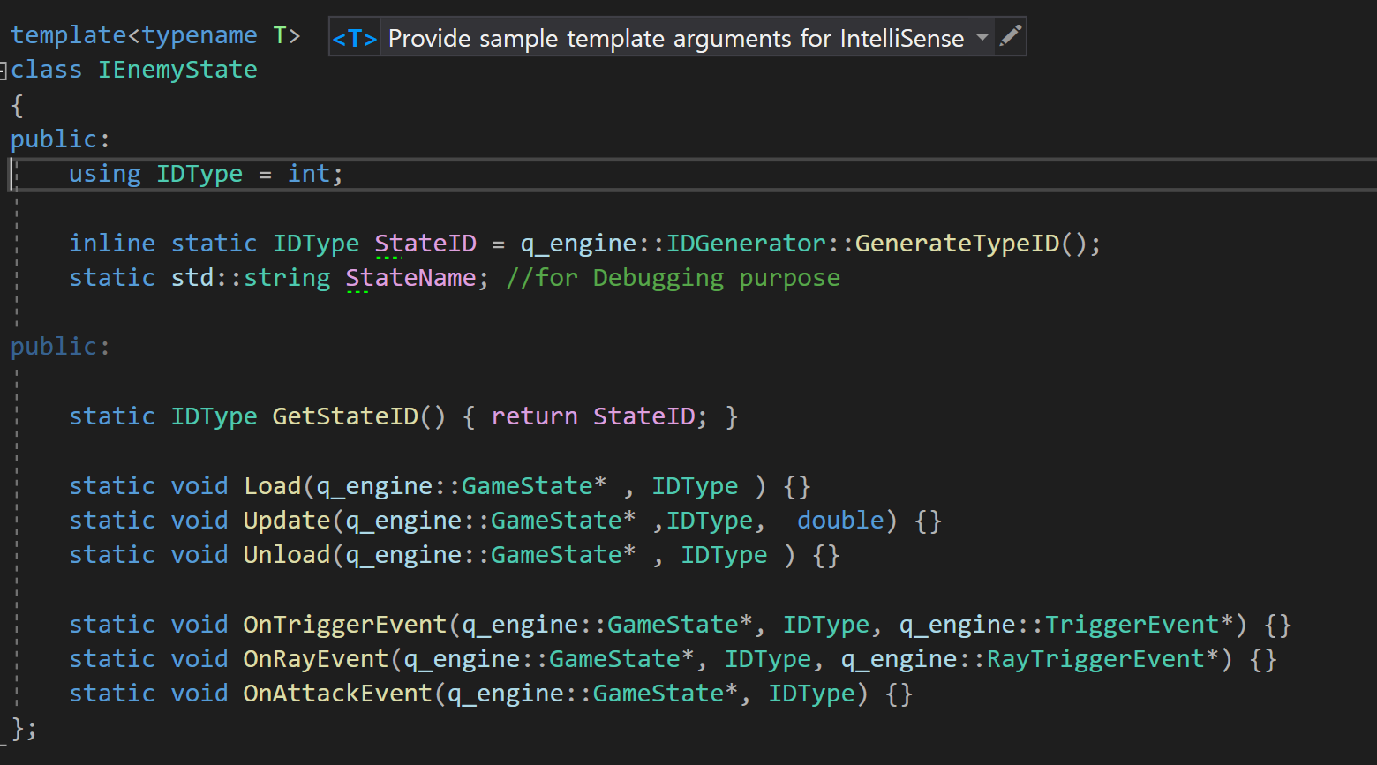
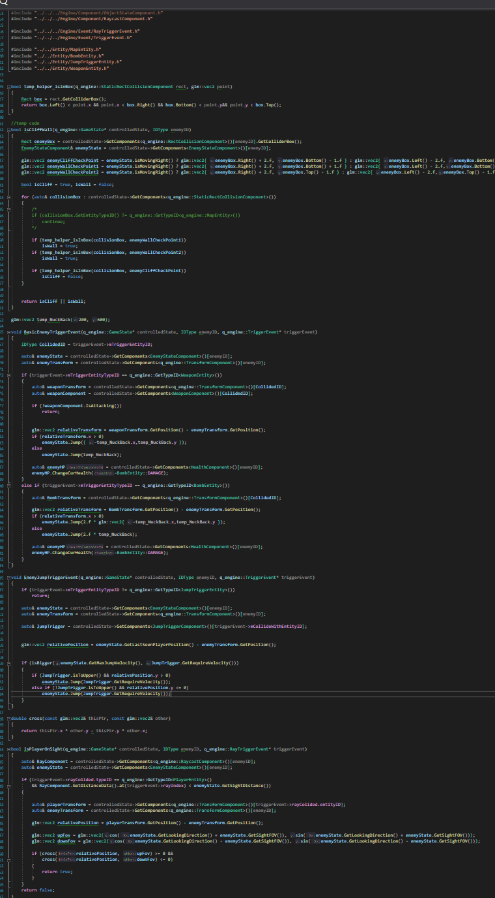

Pre-alpha Trailer
  - I make a trailer for pre-alpha
  - https://drive.google.com/file/d/1W11rC0E7dvba9mbRLOaTcZMnT0sKbMLy/view?usp=sharing
  - I was trying to add some 3D motion graphics. It was quite unsatisfactory.
  - I want to add more cool transitions to the trailer but due to bugs on After Effect, I can’t.
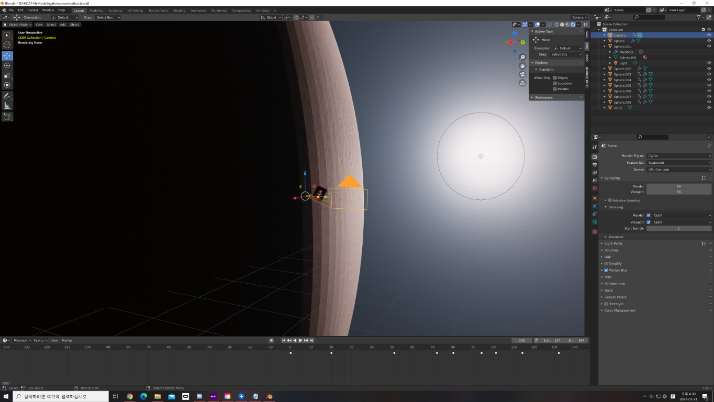

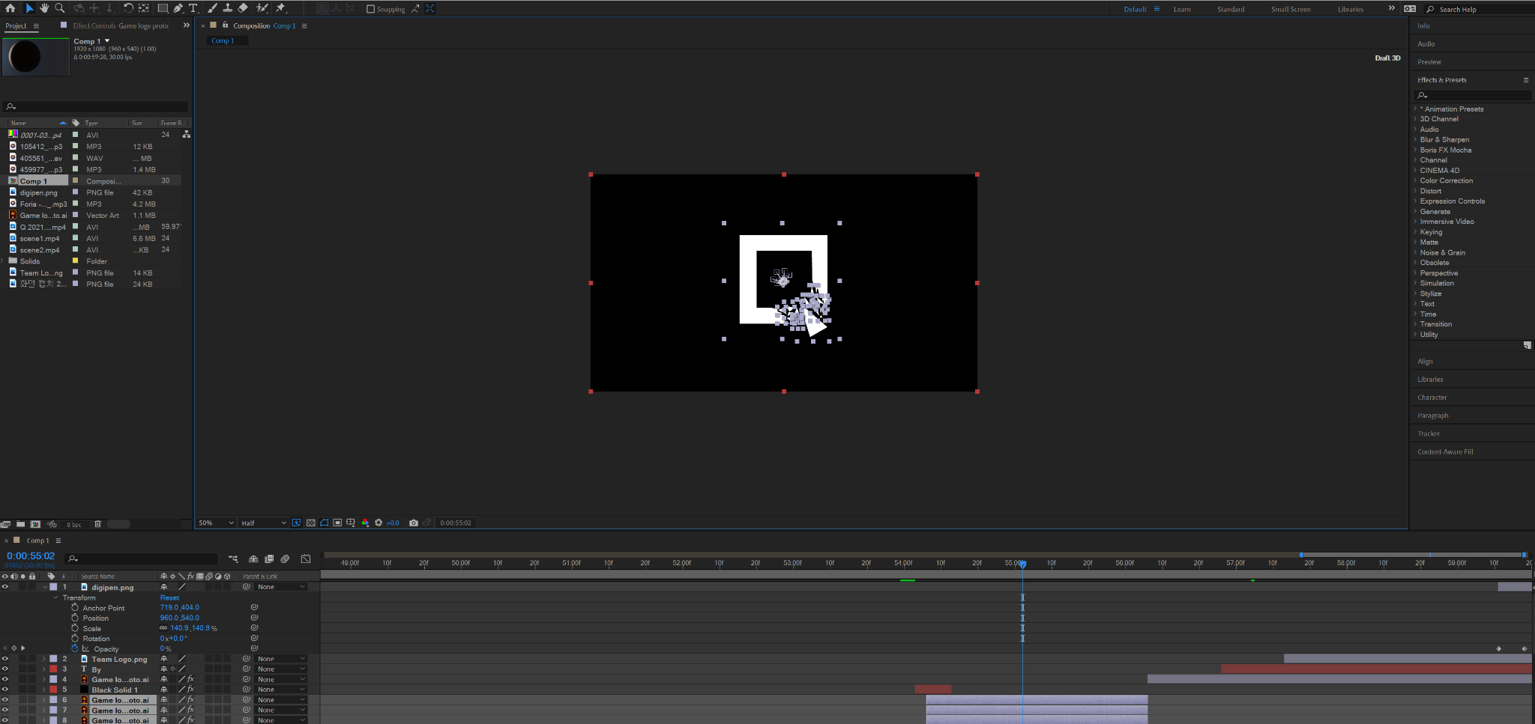

Notes :

